q

Airell Rasendriya Bachtiar

airell.bachtiar@student.fontys.nl

Kasintu

Web Collection Game

Applied Research Document

Semester 3 - Individual Project

Table of Contents

**1.** **Version** 2

**2.** **Introduction** 3

2.1. Purpose 3

2.2. Definitions, Acronyms, and Abbreviations 3

**3.** **System Overview** 3

3.1. Description 3

3.2. Main User Activities 3

3.3. Project Goal 3

**4.** **Problem** 4

**5.** **Main Question** 4

**6.** **Sub Question** 4

**7.** **Methodology** 4

**8.** **Answer** 4

**9.** **Conclusion** 11

**10.** **References** 12

# **Version**

|  |  |  |
| --- | --- | --- |
| **Version** | **Date** | **Description** |
| 0.1 | 25-03-2022 | Make research document |
| 0.2 | 14-04-2022 | Update research document based on feedback |
| 1.0 | 16-06-2022 | Version 1.0 of research document |

# **Introduction**

## Purpose

The purpose of this document is to provide detailed architecture design of a game called Kasintu for individual project at Fontys University of Applied Science.

## Definitions, Acronyms, and Abbreviations

* Gacha: A method inspired by toy vending machine where you can get a toy randomly from what the vending machine provide. Instead of toy vending machine, here it is turned into an application game where you can get an item, in this project we called a creature, randomly with a set number of chances.
* Summon or Pull: The action performed when you are getting a creature from the gacha.
* Banner: The place where you summon or pull creature. Banner contains a list of creatures in which the player can obtained and a chance or percentage of how many chances you can obtain a specific creature.

# **System Overview**

## Description

This game is called Kasintu which means bird. Kasintu is a collection-based game where player can collect as much as they want. What they will collect is a different type of birds that is real and fictional thus the meaning of Kasintu is bird, a game where you collect birds. From now on these birds will be called creature.

## Main User Activities

The main feature of this game is called a gacha system. Gacha system is where player can get a chance to receive a virtual item using in game currency. This is where player mainly get a new creature that will be release or has been released by the developer. They called this action of obtaining new creature as a summoning or pulling. In this case we will call this action as summon or summoning. As the where they summoning these creatures is called a banner. A banner contains a certain amount or all the creature available that can be obtained by the player who summoned on that banner.

For a future feature, Kasintu will also include a marketplace and breeding system. Marketplace is where player can but, sell or trade creatures from the other player. Breeding system is where player can breed their own creature to make new creature which may become rarer that the previous creature.

## Project Goal

The goal of this project is to have a game that will entertain user by collecting creatures and to collect everything the game provides. For better user experience, this game will have to has a fast user interface to make user does not need to wait long in between action or input and a secure application so that data from user cannot be tracked or stolen by a third party.

# **Problem**

The future feature for this game is for player can breed 2 creatures to make new creature. To make new creature, combination of characteristics of the 2 creatures that are bred should be present.

# **Main Question**

How will the simulation of genetic inheritance in Kasintu game?

# **Sub Question**

1. How does genetic inheritance work in biology?
2. How does a mutation work?
3. How other games implement the breeding system in their game?
4. Which characteristics of a creature can be inherited?
5. What methods of choosing characteristics work best for this game?
6. How to implement mutation to a creature?

# **Methodology**

For all the sub question, some form of literature study should be done. There are a lot of information that are already available on the internet and thus, literature study would be helpful for every question to be answered.

The first 3 sub questions, a lot of literature study should be done because it is out of scope as an ICT student. It involves biology and beside the materials we received from school, we don’t learn it anymore. And the third question is about other game method of tackling the problem.

For the last 3 sub questions, it asks more about what to implement, decisions, and approaches that we will be doing. Analysis from the problem, the question itself, and information we gather from the previous sub questions. From there we will decide what our solution is from the problem.

# **Answer**

1. Genetic is a study of genes and heredity of how a certain qualities or traits are passed from parents to offspring and thus it changes the DNA sequence. (National Institute of General Medical Sciences, 2021) Chromosomes are in every cell of the body inside its nucleus. A chromosome stored a long strand of genes. Genes stored a deoxyribonucleic acid or DNA. A collective line of DNAs is called gene. DNA is made of proteins, and it is the one which responsible for storing information of the genetic of a living thing. DNA strand looks like a twisted ladder which each steps contains an information on building a specific molecule. This combination can make up a trait of a living thing. (Better Health Channel, n.d.)

Parents pass on traits or characteristics through their genes. To make up a characteristic, two or more of combined alleles is needed. Allele is two or more genes that may occur alternatively at given site on a chromosome. These combinations of alleles that makes up a gene where this gene responsible for a characteristic is called genotype. (Rogers, n.d.) Genotype is expressed when the information encoded in the genes’ DNA is used to make protein and ribonucleic acid or RNA molecules. Genotype of an individual influences their phenotype. Phenotype is the physical trait that can be observed outside, and it caused from their genetics make up. (Christopher P. Austin, n.d.)

For example, if we are talking about the genotype for eye colour, an individual who has one dominant brown eye allele (B) and one recessive blue eye allele (b). Combined, it will be written as Bb. As a result, the individual phenotype will be brown eye. This method will be explained further in Mendel’s Law of Inheritance.

Mendel’s Law of Inheritance has 3 laws but we will focus on one, law of dominance and uniformity which explain there are 2 different kinds of alleles, dominant and recessive; an organism with at least 1 dominant allele will display the effect of dominant allele. (Wikipedia, 2022) From the example above of the eye colour, if we take the parents of that individuals and they both brings a blue eye genetic will have Bb genotype. If we cross Bb with Bb, it will have 3 possibility or using the formula (B + b)2 it will equals to B2 + 2Bb + b2. To be exact the 3 possibility is BB, Bb, and bb with the number of 1, 2, and 1 respectively. This means getting BB will has a 25% chance, Bb has 50%, and bb has 25%. For the phenotype, it will give a 75% chance of the offspring have brown eyes and 25% of getting blue eyes. Image below is the visual representative of the possibility of crossing between Bb x Bb and Bb x bb. (Better Health Channel, n.d.) (College of Arts and Science, n.d.) (Northern Arizona University, n.d.)

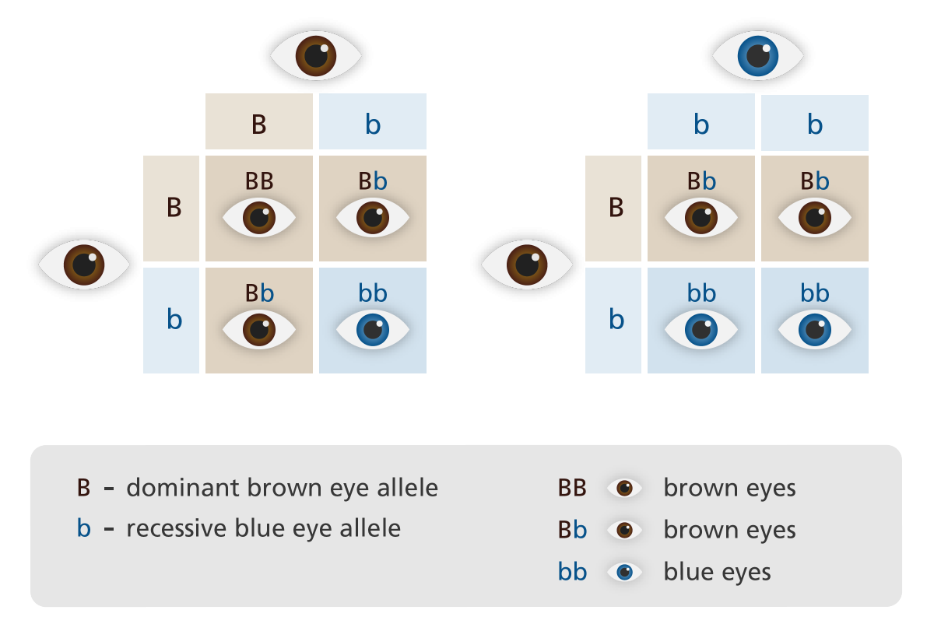

Image on top is the Punnet Square in its simplest form. It will show you different possibility of the combination of the 2 given. Using this method, we can determine all the possibility of the inherited attributes. Below is the example of 2 traits that can be counted using Punnet Square.

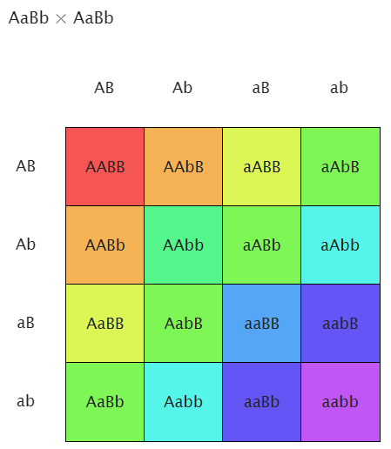

From the formula before, we can use the formula (a + b) with the power of the number of letters of the genotype in this case is 4. So, the formula will be (a + b)4 which equals to a4 + 4a3b + 6a2b2 + 4ab3 + b4. Image below is the probability of the offspring from getting the genotype. The number of probabilities of genotype will match the calculation. (Science Primer, n.d.)

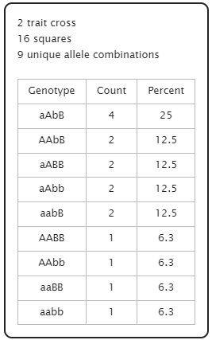

1. Mutation is a change in a DNA sequence. Mutation happens when there is an error during cell division where DNAs are copied. (National Human Genome Research Institute, n.d.) This changes usually doesn’t harm a living thing, but some may result in unfortunate situation like disease derived from mutation.

Mutation has a small chance of occurring and it differs between species and regions. There are many contributing factors of getting a mutation, but it is sometimes unnoticeable. Therefore, living things evolve, through this mutation, there are many kinds of living things in earth, and it took times for a species to evolve to different kinds. (Wikipedia, 2022)

The mutation rate for human is around 3 – 2.7 x 10-5 per base per 20 years generation. This rate is slow considering the fastest mutation rate ever recorded is from an RNA virus and it has 10-3 to 10-5 per base per generation and viruses’ reproduction rate is one of the fastest. (Wikipedia, 2022)

1. We will look how it works in a currently popular NFT game, Axie Infinity. Axie Infinity is a collection game where player can collect creatures as their pets. With that pet they can battle with them, breed them, raise them, and build a kingdom out of them. I think, a lot of people play this game is partly because it can generate money by selling and buying the creature called Axie. In order to obtain your first Axie, you have to buy it with cryptocurrency. (Pagkatotohan, 2022) And after you have obtained first Axie, you can start to play the game, keep progressing with your Axie and as you play it regularly and your Axie will get stronger, you can eventually sell it to get profit if your Axie has a high demand in the marketplace.

One of the main features Axie Infinity is the breeding system. Through breeding, player can get better Axie offspring from their “parents”. (Axie Infinity, 2021) This is the goal of Kasintu breeding system where you can get new creature that are rarer than your previous one, and this how player will keep trying to breed more creatures with different combination.

Axie Infinity has a set amount of breeding attempt for each Axie; 7 times with the price getting higher each time as the counter rise. Each Axie has 6 body parts, and each part possesses 3 genes, a dominant gene and 2 recessive genes. The dominant genes have a 37.5% of inheriting it to its offspring, the first recessive genes (R1) have a 9.375%, and the second recessive genes (R2) have a 3.125% of inheriting it to its offspring. The chosen genes can be either in the dominant slot, R1 slot, or R2 slot. From this mechanic, the offspring have a chance of getting the recessive genes to become its dominant genes.

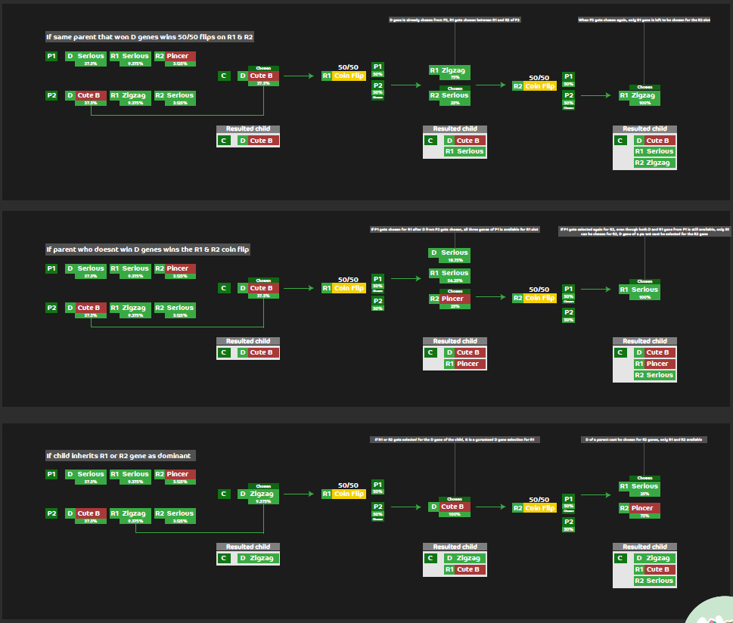

From the image above, we can get a clearer understanding how the genes are chosen in Axie Infinity. By using this mechanic, we only have a chance of getting 1 out of 3 traits. (simpan83, 2021) (Miner, 2021) This breeding method is easier to guess the end result off the offspring and limiting it to a chance of getting 1 out of 3 traits and it doesn’t have a room for an additional trait which all the past generation had.

1. A creature will have few attributes that will be different based on what traits it got, for example, creatures will all have eye colour, but it will be different from each other. Some may have black coloured eye, some may have brown coloured eye, and few may have the rarest colour of them all, purple coloured eye. The attributes could also be clothes that the creature wear, for example, a creature wearing a hat and it could be the colour black or whatever colour it could be. That’s the base idea of the reward of breeding 2 creatures.

Attributes that are within a creature from Kasintu that are based from birds and is unique is wings, beaks, and feathers. (Ullman, n.d.) These characteristics is a must have anatomy to every bird, since it is not highly accurate and just a fictional game, we will count animal that is not bird but have those attributes especially wings, is a bird, like bats. And to get more uniqueness out of one creature, we need more than 3 attributes that can have different traits. We will include the shape of bird’s feet, eye colour, and feather colour.

So, attributes that can change from the traits each creature bring is the type of wings, type of beaks, type of feet, feather, and eye colour. The type of wings includes elliptical wings, hovering wings, high speed wings, active soaring wings, passive soaring wings, and hand wing (exclusive for bats). (Sparks, 2022) Type of beaks include, hooked beaks, cone shaped beaks, short beaks, straight beaks, long beaks, wide beaks, spatulate beaks, large beaks, crossbill beaks, multifunctional beaks, and nose (exclusive for bats) (High Touch High Tech, 2020). Type of feet include, zygodactyl, heterodactyly, syndactyly, pamprodactyly, didactyly, and bat feet (exclusive for bats) (Laurent, 2021) Eye colour and feather colour includes, black, white, brown, red, green, blue, yellow, and purple.

For additional information of attributes, we will also include the measurement of the bird, this includes wing span, height, and weight. (Wikipedia, 2022) From those measurement we can determine what whether the bird is in the bigger size or smaller one, this measurement will be categorized from the smallest to the biggest as microscopic, pygmy, runt, small, ordinary, huge, giant, enormous, and ginormous. (Fandom, n.d.) This measurement categories can be count from each individual measurement. Ordinary would be the normal and average size creatures have and based on how high or low the actual creature has; it can be categorized as those categories. Every 5% of the ordinary size of a creature, it will either go up or down from the default category: ordinary. For example, we have a creature called Snowy Owl. It has average length of 58.7 cm, wingspan of 146.6 cm, and a weight of 1,658 gram. (Wikipedia, 2022) From those measurement, every ordinary size, it would have those measurement ± 5%. If the snowy owl you obtained has length of 65.8 cm (+10.4%), wingspan of 137.9 (-5.9%), and weight of 1,517 gram (-8.5%), its length will be categorized as enormous, wingspan as runt, and a weight of small.

We will also have to take account of the rarity. All creatures have 1 rarity, and its offspring should have one. Based on what creatures you breed; the rarity will vary based on its parents. If you bred a common rarity with a legendary rarity, it would have a chance of getting an offspring with a common rarity to legendary rarity with a chance of getting higher rarity than before, this includes uncommon rarity, rare rarity, and epic rarity. But if you breed between rare rarity with epic rarity, it will produce an offspring between rare rarity or epic rarity or with a small chance of getting higher rarity. Because in the ladder of rarities, there is no rarity type between rare rarity and epic rarity. To obtain a higher rarity more difficult, each rarity type will be given a fixed value that will correspond with the chance of getting it much like the rate of getting those rarity when summoning a creature.

1. Breeding will involve 2 creatures as the parent of the resulting offspring. Parent A will have a gene that will be combined with Parent B and the result of the gene will be carried by Offspring. Attributes will include wing, beak, feet, feather, eye, height, wingspan, weight, and rarity. There are 9 attributes in total, the first 5 will be stored in a gene string where it will store the data of every gene the creatures carry even it is not shown physically. The last 4 of the attributes will be calculated during the breeding process and previous data will not be saved. Generation of the creature will be saved as well. The generation is calculated by the highest generation held by its parents plus 1. So, if the parents have 2 and 3 generations, its offspring will have the value of 4 for its generation since the higher generation is 3 and add 1.

When creatures bred, their genes value will be divided into 2 and combine, this method is to avoid higher number than the previous one since. After combining the 2 genes, the dominant traits will be chosen.

Creature will show the dominant traits of each attribute and this trait will be shown physically in the creature. Creature will have 1 dominant gene and a string of genes. The way that traits are going to be chosen is 20% from dominant gene and 80% from the string of genes. If the string of the genes is chosen, based on the value of traits it holds, it will give you a trait based on chance from the value. If one has been chosen, it will become the dominant trait of the offspring and the value beside the chosen trait will be reduce by 10% and the value taken will be added to the value of the chosen trait in the string of gene.

So, for small example of how it would be implemented, we need to declare a code for attributes and traits. We will use the attributes for eye colour with the code ECO, and the colour with, BLK, WHT, BRW, RED, GRN, BLU, YEL, and PUR. There will be part of a string of gene that solely for eye colour. The string will be as the following: ECO=WHT:34;RED:28;YEL:20;PUR:18;. Here, the separator from each trait will be the symbol ‘;’ and the declaration of an attribute will be ‘=’. And for the separator of each attribute in the string of gene will be other symbol beside that. That traits value is calculated from the parents’ eye colour trait value divided by 2 and then combined. After we get that part of string of gene, dominant value will be chosen. If the yellow colour won, every colour value will be reduced by 10% and the total value taken will be added to yellow. Therefore, the attributes will be as the following: ECO=WHT:30.6;RED:25.2;YEL:28;PUR:16.2;.

Beside the string of genes, the size of the creature and its rarity would be counted. The explanation of how measurement and rarity will be determined is already available in previous paragraph. To be clearer, measurements are generated at random based on its parents’ size plus 10% higher and lower. This way, new creature can be bigger than their parents.

1. To make it more exciting for player to breed creatures, mutation of a genes can be implemented though it has a very low chance of getting it. Every time a player breed there will be 0.01% of getting it. Whenever a creature successfully mutated, it will have a new attribute. This attribute will include a horn type and it can be extendable but for now it will be just horn type. Horn type will have antlers, rhino horn, and buffalo horn. If the offspring got the mutation, attributes will be chosen, and it will give a one of the traits available. The value of the traits will be on 5 as the default value. Even when the offspring got the mutated gene, the chance of getting it as the dominant is low. If it only has a value of 5, it means it has 5 out of 100 of getting it as the dominant gene. If it’s not chosen, the offspring will only be the carrier of horn gene.

The other way would be, when mutation occurs, a special trait will be chosen that are not present in any default creatures’ genes. For example, a special trait for a wing, fiery wing, are setup to be a special trait and a creature mutated in wing types, fiery wing will be chosen as the mutated gene with the value of 5 in exchange of a random 5 value for any genes present.

So, rather than added a new attribute just for a mutated gene, a declared attribute with new special trait will be preferred. This way it is easier to add a new special trait to the system. Special traits will be present in type of wings, type of feats, type of feet, feather, and eye colour or every attribute that carry a gene. Special attributes for wings will be, fiery wings and metal wings. Type of beaks will be, crocodile (crocodile’s snout) and Smilodon (2 long fangs like the prehistoric tiger). Type of feet will be lion feet and horse feet. Feather and eye colour will have a new colour such as, pink and silver.

# **Conclusion**

Kasintu will have a new mechanic of breeding. Based gene will be implemented in the original creature where player can obtain through the gacha system. The string of gene will have a value of attributes with the value of getting it. And it is extendable for new value like the mutated gene. As the generation grew, the varier the gene would be, and more combination possibility will rise.

Breeding will combine 2 attributes from parents resulting new unique offspring. Attributes will include, type of wings, type of beaks, type of feet, feather colour, and eye colour. A measurement of a creature will be saved such as its height, wingspan, and weight. The way attributes’ traits and measurements are determined are already explained in question 4 and 5.

The attributes have multiple traits that can be present in creatures. Type of wings will have, elliptical wings, hovering wings, high speed wings, active soaring wings, passive soaring wings, and hand wing (exclusive for bats). Type of beaks will have, hooked beaks, cone shaped beaks, short beaks, straight beaks, long beaks, wide beaks, spatulate beaks, large beaks, crossbill beaks, multifunctional beaks, and nose (exclusive for bats). Type of feet will have, zygodactyl, heterodactyly, syndactyly, pamprodactyly, didactyly, and bat feet (exclusive for bats). Feather colour and eye colour will have, black, white, brown, red, green, blue, yellow, and purple.

In the process of breeding, mutation can occur with the rates of 0.01%. When creature receive a mutation, attributes’ traits will be added to their genes. These special traits will be present in type of wings, type of beaks, type of feet, feather colour, and eye colour. Type of wings will have fiery wings and metal wings. Type of beaks will have crocodile snout and Smilodon teeth. Type of feet will be lion feet and horse feet. Feather colour and eye colour will have pink and silver.

# **References**

(n.d.). Retrieved from Better Health Channel: https://www.betterhealth.vic.gov.au/health/conditionsandtreatments/genes-and-genetics

(n.d.). Retrieved from Science Primer: https://scienceprimer.com/punnett-square-calculator

(n.d.). Retrieved from Northern Arizona University: https://www2.nau.edu/lrm22/lessons/hwe/hwe.htm

(n.d.). Retrieved from College of Arts and Science: http://www.bio.miami.edu/dana/dox/trinomial.html

(n.d.). Retrieved from National Human Genome Research Institute: https://www.genome.gov/genetics-glossary/Mutation

(n.d.). Retrieved from Fandom: https://sorb-pixelmon.fandom.com/wiki/Growth(Stat)

(2020, April 29). Retrieved from High Touch High Tech: https://sciencemadefun.net/blog/birds-beaks-and-adaptations/

(2021, 12 8). Retrieved from National Institute of General Medical Sciences: https://www.nigms.nih.gov/education/fact-sheets/Pages/genetics.aspx

(2021, November). Retrieved from Axie Infinity: https://whitepaper.axieinfinity.com

(2022, February 23). Retrieved from Wikipedia: https://en.wikipedia.org/wiki/Mendelian_inheritance

(2022, March 22). Retrieved from Wikipedia: https://en.wikipedia.org/wiki/Mutation_rate

(2022, March 15). Retrieved from Wikipedia: https://en.wikipedia.org/wiki/Mutation

(2022, March 6). Retrieved from Wikipedia: https://en.wikipedia.org/wiki/Bird_measurement

(2022, March 6). Retrieved from Wikipedia: https://en.wikipedia.org/wiki/Snowy_owl

Christopher P. Austin, M. (n.d.). Retrieved from National Human Genome Research Institute: https://www.genome.gov/genetics-glossary/genotype

Laurent, A. (2021, January 6). Retrieved from Animal Wised: https://www.animalwised.com/types-of-bird-feet-3475.html

Miner, L. (2021, September 21). Retrieved from https://drive.google.com/file/d/1tPigbo98A5DrlqXzD4EfzbjqzFIZNBGo/view

Pagkatotohan, J. (2022, March 29). Retrieved from Moneymax: https://www.moneymax.ph/personal-finance/articles/axie-infinity#3_Get_Your_Axies

Rogers, K. (n.d.). Retrieved from Britannica: https://www.britannica.com/science/allele

simpan83. (2021, September 18). Retrieved from https://www.reddit.com/r/AxieInfinity/comments/pqnlc5/how_r1_and_r2_genes_are_inherited/?utm_medium=android_app&utm_source=share

Sparks, R. (2022, March 9). Retrieved from Optics Mag: https://opticsmag.com/types-of-bird-wings/

Ullman, M. (n.d.). Retrieved from Pets on Mom: https://animals.mom.com/5-major-characteristics-birds-5792.html